Chandler, Robert J
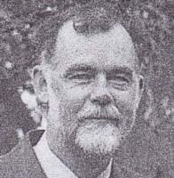
BSc Forestry ANU. In Dieback mapping group at Manjimup in 1970s. Promoted to Regional Planning Officer at Bunbury in 1990. Regional Manager Central Forest Region in mid 1990s-2000s. Regional Manager South West, based in Bunbury 2006.

